A

Mini Project Report

On

Travel Agency

By

Syed Salman(1604-14-737-037)

Mohammed Anas(1604-14-737-039)

Imadullah Sharief(1604-14-737-040)

of

II/IV B.E. Sem-I (IT-A)

Under the Guidance of

Mohd Sarfaraz Ahmed, Assistant Professor, ITD.

Md. Ibrahim khalilullah, Assistant Professor, ITD.



**DEPARTMENT OF INFORMATION TECHNOLOGY**

**MUFFAKHAM JAH COLLEGE OF ENGINEERING AND**

**TECHNOLOGY (Affiliated to Osmania University )**

Mount Pleasant, 8-2-249, Road No. 3, BanjaraHills, Hyderabad-34**.**

**MUFFAKHAM JAH COLLEGE OF ENGINEERING TECHNOLOGY**

(Affiliated to Osmania University )

Mount Pleasant, 8-2-249, Road No. 3, Banjara Hills, Hyderabad-34.



**DEPARTMENT OF INFORMATION TECHNOLOGY**

***CERTIFICATE***

This is to certify that the Mini Project work titled “Online Book Store” is a bonafide work prescribed by the Osmania University for B.E II,III/IV IT I/II Semester during the academic year 2013-14 carried out by Syed Salman(1604-14-737-037), Muhammed Anas(1604-14-737-039) and Imadullah Sharief(1604-14-737-040)

Faculty Incharge

**ACKNOWLEDGEMENT**

The austerity and satisfaction that one gets on completing a project cannot be fulfilled without mentioning the people who made it possible with gratitude.

We are grateful to the almighty God who helped us all the way throughout the project and also has molded us into what we are today. We express our sincere thanks to our parents who encouraged us always to achieve our goals.

We offer our sincere thanks to Muffakham Jah College of Engineering and Technology for allowing us to do our mini project in their esteemed institution.

We show gratitude to **Dr. K. N. Krishnan sir, M.Tech, PhD** and **Principal** for having provided all the facilities and support. We would like to thank **Mrs. Maniza Hijab ma'am**, (**Head of the Department, Information Technology)** for her expert guidance and encouragement at various level of project.

We are Thankful to our guide **Mohammed Sarfaraz Ahmed, Assistant Professor ITD** and for his sustained inspiring Guidance and cooperation throughout the process of this project report.

We express our deep sense of gratitude and thanks to all the **Teaching** and **Non-Teaching Staff** of our college who stood with us and helped us to make it a successful venture.

**ABSTRACT:**

The main objective of the project *T*ravelling Agency is to make avail to the customers all sorts of travelling services. A host of services such as registration, display, search, modify etc are provided. In the registration step, the client has to provide his personal details.Travel agencies have to deal with a lot of customers daily. Hence it is very important to maintain records of all the customers. For this purpose we require software that makes it easy to maintain the customer details. The records of various customers can be stored in a single file. In this project facilities like registration, search, display, modification, delete etc. are provided. The software searches the client data in the database it has created. Moreover the software designed here is used to arrange travel services, give new and improved services and also identify travel related cost savings.In the modify option, customer details can be changed or updated. In the delete option, record of the particular client such as his name, address and other details are deleted from the database.In the option of display all the client information is read like name, phone, cost etc. in the search tab, if information of a particular client is required, then that be obtained.

**CONTENTS**

Page number

1. Introduction 1

2. Literature survey 2

3. Software Requirement Specification 4

4. System Design 5

4.1 Flow Diagram 6

5. Implementation 8

6. Testing 10

7. Screenshot 11

8.Conclusion 14

9. Reference 15

**1. INTRODUCTION**

The main objective of the Project on Travel Agency is to manage the details of Charges, Payments, Bookings, Cabs, Customer. It manages all the information about Charges, Travel Agency, Customer, Charges. The project is totally built at administrative end and thus only the administrator is guaranteed the access.

The purpose of the project is to build an application program to reduce the manual work for managing the Charges, Payments, Travel Agency, Bookings. It tracks all the details about the Bookings, Cabs, ticket booking, cancelling of tickets, show the available trains and their arrival and departure time in case of railways. Similarly, it shows the available domestic and international flights (one way, round way journey), select their day of departure, select their day of arrival, gender (male or female), no.of adults and no. of children, the type of class (business or economy) and then according to their input it should generate the fare

**1**

**2. LITERATURE SURVEY**

**INTRODUCTION:**

The main objective of the Project on Travel Agency is to manage the details of Charges, Payments, Bookings, Cabs, Customer. It manages all the information about Charges, Travel Agency, Customer, Charges. The project is totally built at administrative end and thus only the administrator is guaranteed the access.

The purpose of the project is to build an application program to reduce the manual work for managing the Charges, Payments, Travel Agency, Bookings. It tracks all the details about the Bookings, Cabs, ticket booking, cancelling of tickets, show the available trains and their arrival and departure time in case of railways. Similarly, it shows the available domestic and international flights (one way, round way journey), select their day of departure, select their day of arrival, gender (male or female), no.of adults and no. of children, the type of class (business or economy) and then according to their input it should generate the fare.

**EXISTING SYSTEM**

In this project, the existing system in todays day to day circumstances are

* It is not reliable.
* It is complex and time consuming in the registration of any means of transport.
* There are less number of service centres in availability.
* There are registrations, receipt options.
* The search for the booking takes longer period of time.

**PROPOSED SYSTEM**

This project provides the facilities to the customer such as registration, display, search, modify, delete etc.

**2**

In *Registration option*add the client information such as client name, address, client no, phone no, total cost of travels, date of registration.

In *Display option*, read the all client information such as client no, client name, address, phone no and cost.

In *search option*, search the information about particular client, such as client no client name, phone no, date of registration and cost.

In *modify option*, update the particular client no, name, address, phone no and cost.  
**ADVANTAGES**

The advantages for choosing a travel agency are:

Convenience we don’t have to besiege embassy and wait in long queues and don’t need to worry about buying tickets and booking hotels. We are free to choose there and when to go, and are free to change you hotel of return ticket. Travel agencies have special agreements with hotels and the price becomes cheaper. The same thing can be said about train tickets.

**3**

**3. software requirement specification**

**1. Functionality**

The functionality requirement specifies which output should be produced from the given input.In **“Traveling agency’’** project, enter the input as all personal data (name, address, phone no, date) & traveling information & give desired output as total cost of traveling.

**2. Performance**

This part specifies performance constraints on the software system. The entire requirement relating to the performance characteristics of the system works properly meeting the needs of the customer. The characteristics of the programing software b which it performs well are:

* Time complexity- How fast the program executes.
* Less defective.

**3. Design constraints**

There are number of factors in the client environment that may restrict the choices of designer. The software program is designed such that it is maintained and performs well.

**4. Maintainability**

This part specifies the maintenance of the project, the software project is maintained such that it is durable and is up to date.

**4. External interface**

All possible interactions of the software with client, hardware & other software are clearly maintained and checked.

**Hardware requirements**

Minimum requirements are

* 64 MB RAM
* 1 GB Hard Disk
* Processor

**Software requirements**

* Turbo C.
* C++.
* Windows XP.

**4**



**4. SYSTEM DESIGN**

In modification option, update the particular name, address, phone no and cost.

In search option, search the information about particular client such as client no

Client name, phone no, date of registration and total cost.

In display option, read the all client information such as client no ,client name, address, phone no and cost and date of Registration.

In Registration option add the client information such as client name, address, client no, phone no, total cost of travels, date of registration .

Following calculations are carried out to calculate the total cost of travels:

1) travels of yellow board :

Total cost of travels=((per km+Temporary pervana(TP))*(total km))

2) travels of white board:

Total cost of travels =(per km*total km)

**5**

**4.1 FLOW DIAGRAM**

Data Files

Display

Registration

Personal data

Client

Customer information

Search

Client Data

Delete

Modify

Enter the client no.

**6**

REGISTRATION

PERSONAL

DATA

BOARD

VEHICLE

SEATS

DAYS

PLACE

ONE

DAY

MORE DAY

WHITE

YELLOW

6

10

16

INNOVA

TRAVEL

INDICA

CLIENT

NO

CLIENT

NAME

CLIENT ADDRESS

CLIENT PHONE NO

REGISTRATION

DATE

7

**5. IMPLEMENTATION**

void travelagency::showhotel()

{

int a,b;

if(top==1)

price=(fst1*kor1*nod)+(fst2*kor2*nod);

else

if(top==2)

price=(tst1*kor1*nod)+(tst2*kor2*nod);

else

if(top==3)

price=(nst1*kor1*nod)+(nst2*kor2*nod);

if(toggle==1)

{

clrscr();

textcolor(WHITE+BLINK);

textbackground(BLUE);

for(int h=25;h<50;h++)

{

gotoxy(20,8);cout<<"Please wait while we make the Reservation";

gotoxy(h,10);cout<<"Û";

delay(250);

}

toggle=0;

}

clrscr();

gotoxy(25,5);cout<<"Hotel Reservation ";

gotoxy(24,6);cout<<"-----------------------";

gotoxy(15,8);cout<<"Name:"<<strupr(name);

gotoxy(15,10);cout<<"Address:"<<strupr(add);

gotoxy(15,12);cout<<"Name of the hotel: "<<strupr(hotel)

<<" , "<<strupr(destination);

gotoxy(15,14);cout<<"No. of Days to stay: "<<nod;

gotoxy(15,16);cout<<"No. of DELUXE rooms reserved: "<<kor1;

gotoxy(15,18);cout<<"No. of NON-DELUXE rooms reserved: "<<kor2;

gotoxy(15,20);cout<<"Your Reservations have been done"

"Please pay the Amount!!!";

gotoxy(25,22);cout<<"Amount: Rs."<<setprecision(2)<<price;

getch();

}

**8**

void travelagency::restr()

{

clrscr();

flag2='N';

while(flag2!='Y')

{

clrscr();

gotoxy(20,5);cout<<"Please Enter Information For Transport Reservation";

gotoxy(20,7);cout<<"Please enter the choice of your mode of transportaion......";

gotoxy(25,9);cout<<"1: by Air";

gotoxy(25,10);cout<<"2: by Train";

gotoxy(25,11);cout<<"3: by Road"<<endl;

gotoxy(26,12);cout<<"......";cin>>top2;

clrscr();

assignprice();

clrscr();

gotoxy(15,2);cout<<"PLEASE FILL IN THE DETAILS ...";

gotoxy(25,5);cout<<"TRANSPORT RESERVATION FORM";

gotoxy(5,8);cout<<"Name: ";

gotoxy(5,10);cout<<"Address: ";

gotoxy(5,12);cout<<"Destination: ";

gotoxy(30,12);cout<<"Mode of Transport: ";

gotoxy(5,14);cout<<"Type of Tickets to be Reserved(1/0)" ;

gotoxy(10,16);cout<<"Executive: ";

gotoxy(30,16);cout<<"Economy: ";

gotoxy(10,22);cout<<"Is the information correct(y/n)?? ";

gotoxy(10,8);gets(name);

gotoxy(13,10);gets(add);

gotoxy(19,12);gets(destination);

gotoxy(50,12);gets(trans);

gotoxy(22,16);cin>>not1;

gotoxy(40,16);cin>>not2;

gotoxy(45,22);cin>>flag2;

flag2=toupper(flag2);

}

showtransport();

}

**9**

**6. TESTING**

**10**

**7. SCREEN SHOTS**

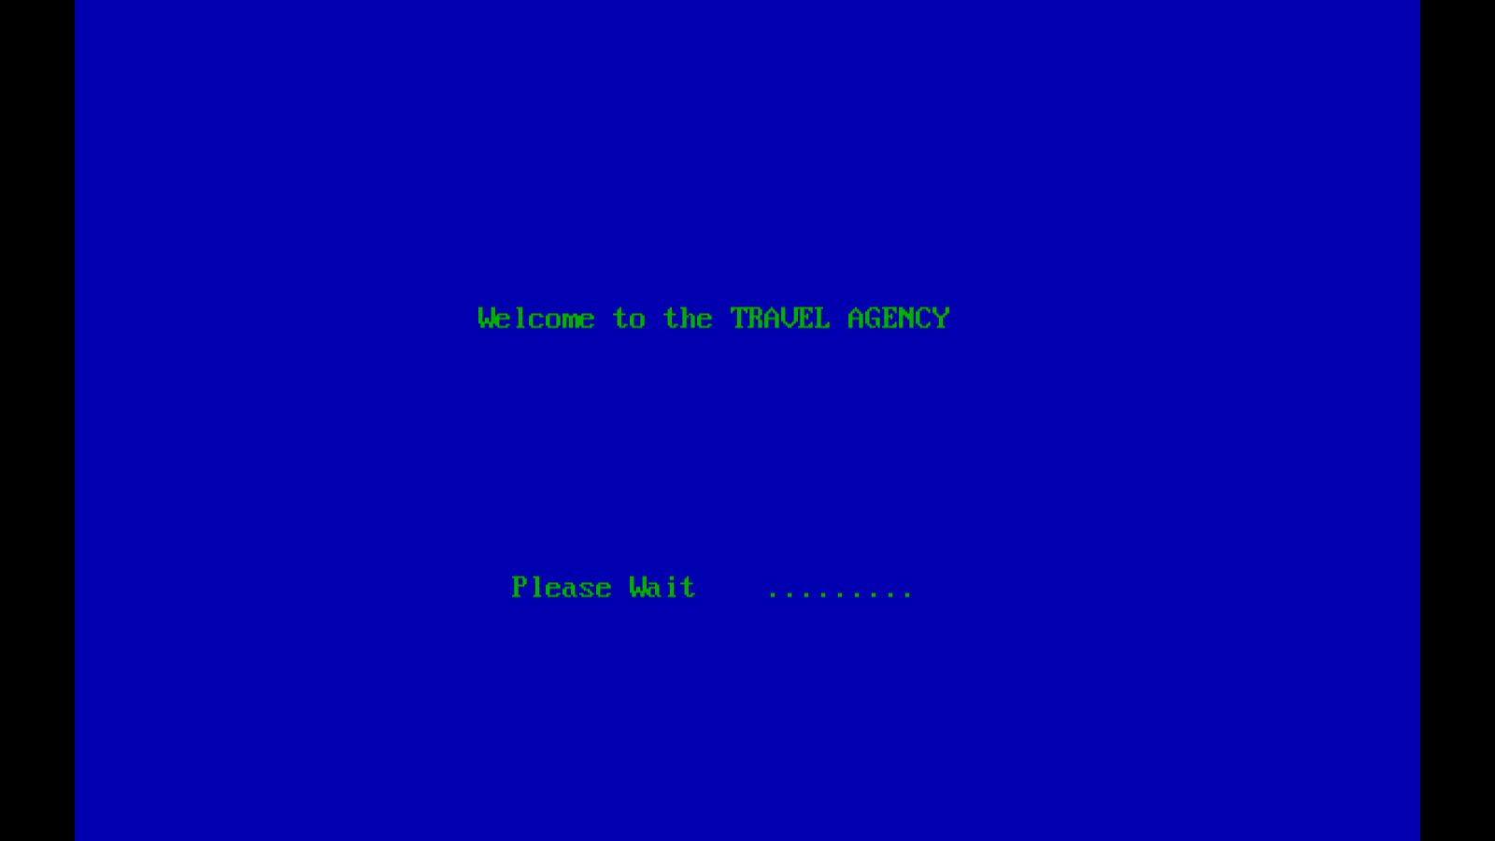

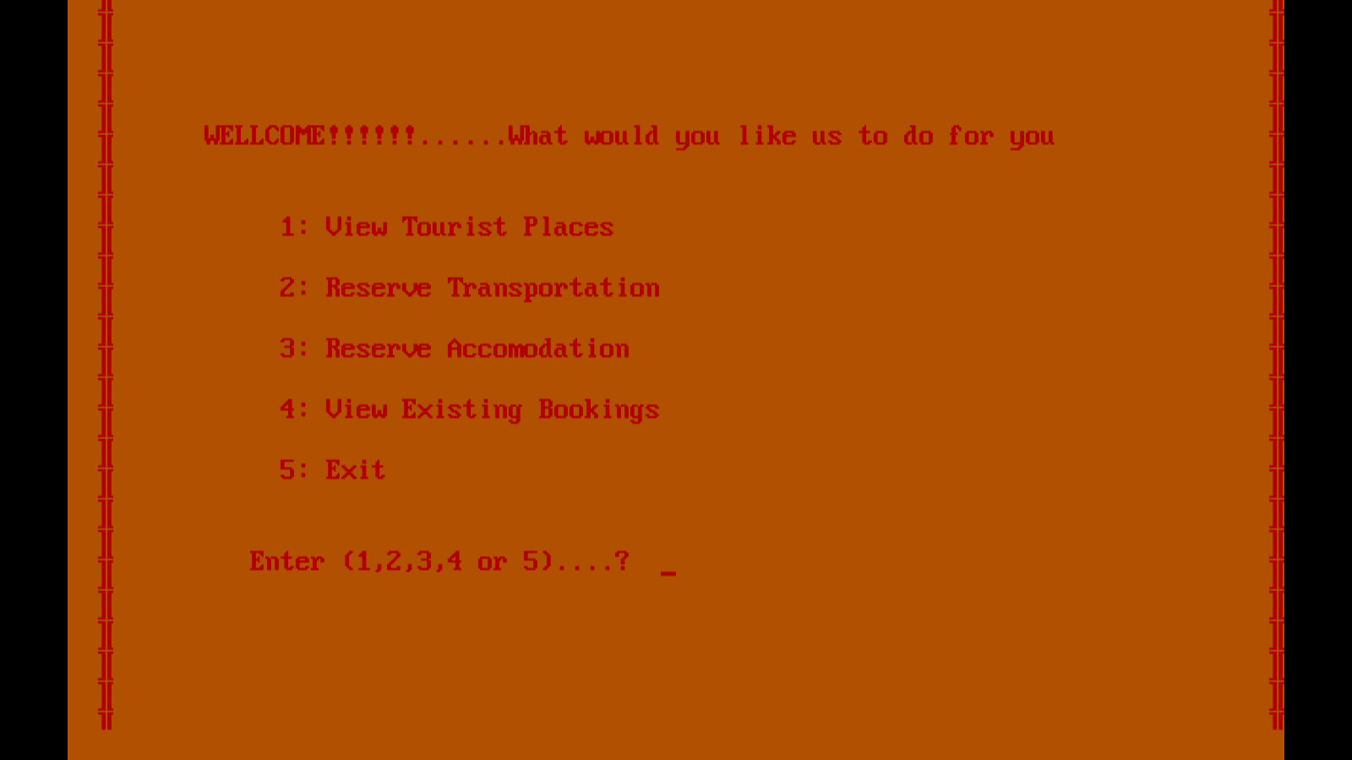

**11**

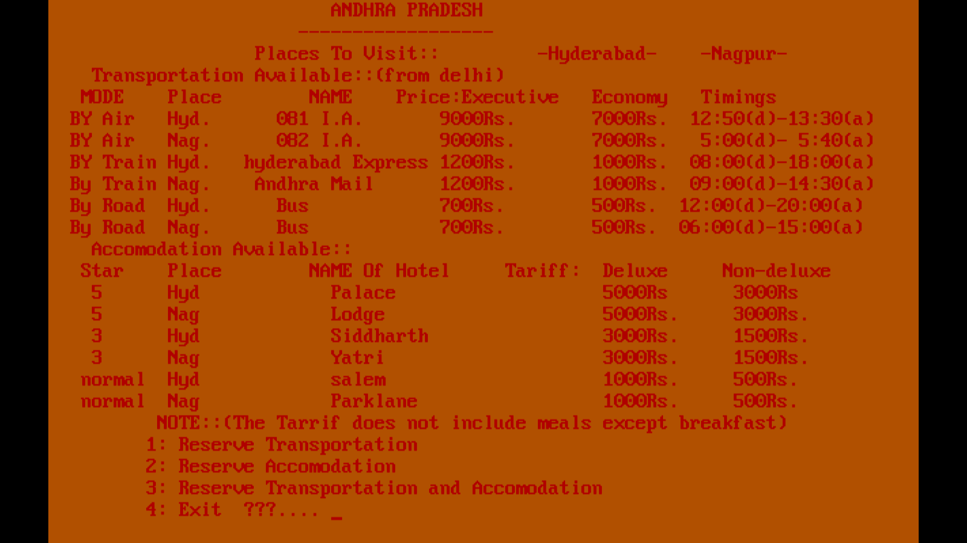

**12**

**8. CONCLUSION**

This project provides the facilities to the customer such as registration, display, search, modify, delete etc. of many aspects in the process of travelling and hotel accommodation.

1. “Travel Agency Management” simplifies the management process in travelling.
2. This project facilitates both hotel accommodation and transport reservation.
3. Fast processing and immediate results.
4. Fast retrieving & user friendly.
5. Minimizing human effort and cost.

**14**

**9. REFERENCE**

1. Google images
2. Wikipedia.org
3. slideshare.com

**15**